Experiment Number : 07 Date: 5-02-26

METHOD OVERLOADING AND METHOD OVERRIDING
Aim:
To understand and implement method overloading and method overriding.
PRE LAB EXERCISE
QUESTIONS
- What is method overloading?
Method overloading means having multiple methods with the same name in the same class but different parameters (different number, type, or order of arguments).
Performed within the same class
Occurs at compile time (static polymorphism)
Example:
void add(int a, int b) { }
void add(double a, double b) { }
void add(int a, int b, int c) { }

- What is method overriding?
Method overriding means a subclass provides its own version of a method that already exists in the parent class.
✔ Performed between two classes (inheritance)
✔ Occurs at runtime (dynamic polymorphism)
✔ Method name, parameters, and return type must be same

- Difference between overloading and overriding.
Method Overloading | Method Overriding
Same method name but different parameters | Same method name, same parameters, different class
Happens within the same class | Happens in parent–child classes
Compile-time polymorphism | Runtime polymorphism
Return type can be same or different | Return type must be the same
No inheritance required | Requires inheritance
Methods have different signatures | Signature is exactly the same

IN LAB EXERCISE
Objective:
To demonstrate compile-time and runtime polymorphism.
PROGRAMS:
1.Student Result System (Method Overriding)
Description:
- Base class Student has method displayResult().
- Subclasses UGStudent and PGStudent override the method to show different grading systems.

Code :
package tutorial;
import java.util.Scanner;
// Base class
class Student {
String name;

void displayResult() {
System.out.println("Student Result");
}
}

// UG Student subclass
class UGStudent extends Student {
int marks;

UGStudent(String n, int m) {
name = n;
marks = m;
}

@Override
void displayResult() {
double percentage = (marks / 100.0) * 100;
System.out.println("UG Student: " + name);
System.out.println("Marks: " + marks);
System.out.println("Percentage: " + percentage + "%");
}
}

// PG Student subclass
class PGStudent extends Student {
double gpa;

PGStudent(String n, double g) {
name = n;
gpa = g;
}

@Override
void displayResult() {
System.out.println("PG Student: " + name);
System.out.println("GPA: " + gpa + " / 10");
}
}

// Main class
public class methodoverriding {
public static void main(String[] args) {
Scanner sc = new Scanner(System.in);

System.out.print("Enter UG Student Name: ");
String ugName = sc.nextLine();

System.out.print("Enter UG Student Marks (out of 100): ");
int ugMarks = sc.nextInt();
sc.nextLine();

System.out.print("Enter PG Student Name: ");
String pgName = sc.nextLine();

System.out.print("Enter PG Student GPA (0-10): ");
double pgGpa = sc.nextDouble();

Student s1 = new UGStudent(ugName, ugMarks);
Student s2 = new PGStudent(pgName, pgGpa);

System.out.println("\n--- Student Results ---");
s1.displayResult();
System.out.println();
s2.displayResult();

sc.close();
}
}

OUTPUT:
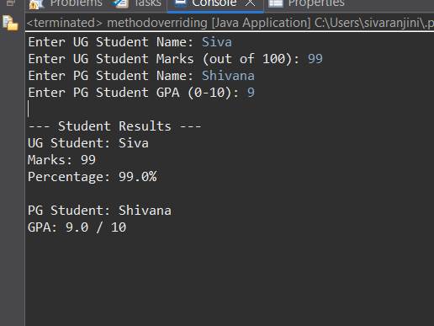
2. Calculator Program (Method Overloading)
Description:
Create a Calculator class with multiple add() methods to calculate:
- Addition of 2 integers
- Addition of 3 integers
- Addition of 2 double numbers
Code:
package tutorial;
import java.util.Scanner;
class Calculator {
// Add two integers
int add(int a, int b) {
return a + b;
}
// Add three integers
int add(int a, int b, int c) {
return a + b + c;
}
// Add two doubles
double add(double a, double b) {
return a + b;
}
// Main method
public static void main(String[] args) {
Scanner sc = new Scanner(System.in);
Calculator calc = new Calculator();
// Two integers
System.out.print("Enter two integers: ");
int x = sc.nextInt();
int y = sc.nextInt();
System.out.println("Sum of two integers: " + calc.add(x, y));
// Three integers
System.out.print("Enter three integers: ");
int p = sc.nextInt();
int q = sc.nextInt();
int r = sc.nextInt();
System.out.println("Sum of three integers: " + calc.add(p, q, r));
// Two decimal numbers
System.out.print("Enter two decimal numbers: ");
double a = sc.nextDouble();
double b = sc.nextDouble();
System.out.println("Sum of two doubles: " + calc.add(a, b));
sc.close();
}
}
Output:
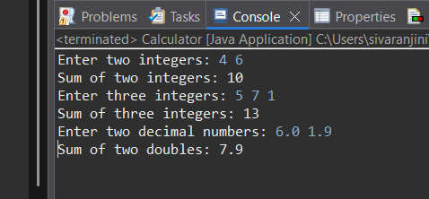
POST LAB EXERCISE
- Is return type important in method overloading and method overriding?
Method Overloading → Return type is NOT important
- Overloading depends only on the method signature
(method name + parameter list)
- Return type is NOT part of the method signature.
- You can have same return type or different return type — it doesn’t matter.
Method Overriding → Return type IS important
- Overriding requires the same return type (or a covariant return type).
- Method signature must be identical to the parent class.

Can you overload a method by changing only the return type?
No, you cannot.
If only the return type changes but parameters remain the same:
int show() { }
double show() { } // ❌ ERROR
The compiler cannot differentiate them because return type is not part of the method signature.
So overloading requires different parameter list, not just different return type.

- Can static methods be overridden? Can they be overloaded?
✔ Static methods CANNOT be overridden
Because:
- Overriding requires runtime polymorphism
- Static methods belong to the class, not the object
- Static methods use compile-time binding
If a subclass has the same static method, it is method hiding, not overriding.
✔ Static methods CAN be overloaded
Because overloading only requires:
- Same method name
- Different parameter list
And static methods support this.

- Can a method be overridden if the parameter list is different?
No.
If the parameter list is different, it becomes overloading, not overriding.
Overriding rules:
- Same method name
- Same parameter list
- Same return type
If parameters don’t match:
class A { void show(int x) { } }
class B extends A { void show(double x) { } } // ❌ Not overriding → Overloading
So parameter list must be identical for overriding to happen.

Result:
Thus the method overloading and overriding concepts were implemented and executed successfully.
ASSESSMENT

Description | Max Marks | Marks Awarded
Pre Lab Exercise | 5
In Lab Exercise | 10
Post Lab Exercise | 5
Viva | 10
Total | 30
Faculty Signature

